1.5.1-CD Registration Manager Class Diagram

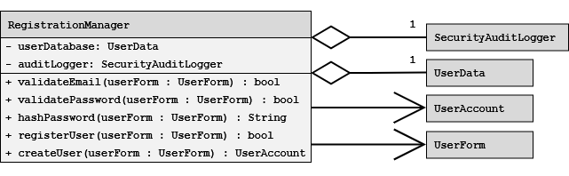1.5.2-CD Authorization/Role Manager Class Diagram

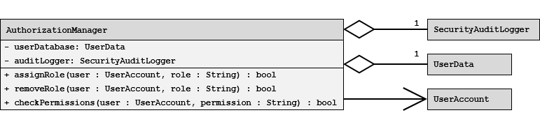1.5.3-CD Login & Session Manager Class Diagram
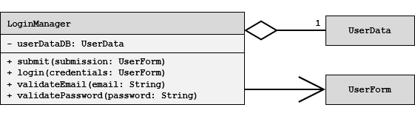

1.6.1-CD Profile Manager Class Diagram

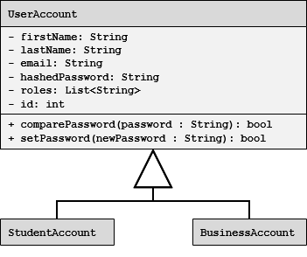

1.6.2-CD Image Manager Class Diagram
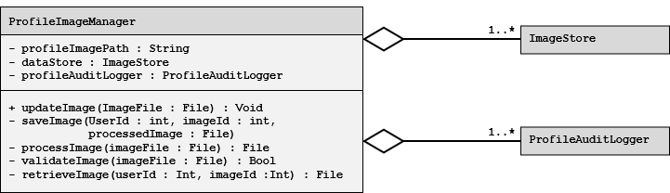

1.6.3-CD Preferences Manager Class Diagram

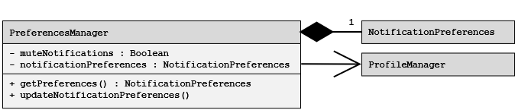1.6.4-CD Privacy Settings Manager Class Diagram

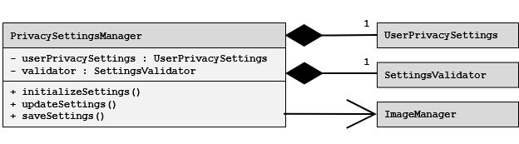1.6.5-CD Profile Audit Logger Class Diagram

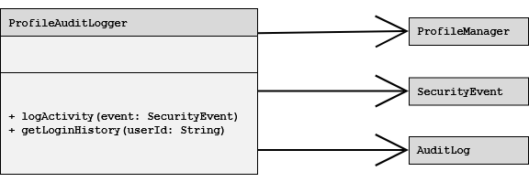

1.6.6-CD User Account Class Diagram


1.6.7-CD Accolade Class Diagram
